**Title: Homicides increase variation on lifespans in Mexico, 2005-2015**

**Authors:** José Manuel Aburtoa & Hiram Beltrán-Sánchezb

**Author affiliations:**

a Department of Public Health, Unit of Biodemography, University of Southern Denmark, Odense 5000, Denmark.

b Department of Community Health Sciences at the Fielding School of Public Health and California Center for Population Research, University of California, Los Angeles, California, USA.

**Corresponding author:**

José Manuel Aburto

Email: [jmaburto@health.sdu.dk](mailto:jmaburto@health.sdu.dk)

Tel. number: +45 65 50 94 16

Affiliation: Department of Public Health, Unit of Biodemography, University of Southern Denmark.

Address: J.B. Winsløws Vej 9. DK-5000 Odense C, Denmark

**Keywords:** violence, lifespan variation, life expectancy, demography, public health.

**Abstract [Max 250-300 words]:**

**Objective**: To quantify the effect of the unexpected increase of violence on life expectancy and lifespan variation in Mexico in the period 1990-2015.

**Design**: Cross-sectional retrospective demographic analysis with publicly available data from the Mexican Institute of Statistics and the Mexican Population Council.

**Setting**:

**Participants**: 64 populations (32 Mexican states by sex) with data on causes of death.

**Main outcome measures**: Life expectancy and lifespan variation with age and cause-specific contributions to the changes between 1995-2005 and 2005-2015

**Results**:

**Conclusions**:

**What is already known on this topic?**

Latin America is the most dangerous region in the world. In Mexico, life expectancy stagnated in the decade 2000-10 due to the unprecedented rise in homicides after 2005 and a continuous increase in diabetes mortality. At the state level, the effect of violence was such that Mexican states lost life expectancy gains in the period 2005-10.

**What this study adds?**

Lifespan variation is an important dimension of population health that expresses heterogeneity in lifetimes at the population level and individual uncertainty in the timing of death. Analyzing life expectancy and lifespan variation simultaneously allowed us to disclose that the Mexican population not only is living less on average but also facing more uncertainty in their age at death due to the increase in homicidal violence. As a result, inequality in lifespans has not declined.

**Introduction [~ 4400 words, 2830 now]**

Violence has become a major public health issue in Latin America since the end of the 20th century.1 This region currently experiences the highest homicide rate in the world (over 16.3 per 100,000 people), with some countries in Central America, including Mexico, undergoing an upsurge in homicides since the first years of the 21st century.2 In Mexico, for example, homicide rates doubled between 2007 and 2012 (from 9.3 to 18.6).3 As a result of this increase, along with an increasing burden of diabetes, male life expectancy in Mexico stagnated in the period 2000-10.4 At the subnational level, evidence indicates that gains in life expectancy due to causes amenable to medical service throughout 2000-10, such as infectious, respiratory diseases and birth conditions, were wiped out by the increase of homicide and diabetes mortality in each of the 32 states in Mexico, with large regional variations.5

Trends in life expectancy are important and have been studied in Mexico and its states.4-6 However, life expectancy masks substantial heterogeneity in individual mortality trajectories,7 8 referred here as lifespan variation. Variability in ages-at-death expresses a fundamental inequality among individuals at the population level and uncertainty in lifetime at the individual level,9 and it has arisen as an important topic since it addresses the growing interest in health inequalities.10 Studying both life expectancy and lifespan variation adds an important dimension to the study of population health because these indicators represent individuals’ decisions based not only on their expected lifetime, but also on the uncertainty in their timing of death.11 Most studies have found a negative association between these two measures, suggesting that as life expectancy increases, variation in lifespans decreases.8 12-14 However, at the subnational level some evidence suggests that increases in lifespan variation may simultaneously occur with increases in life expectancy, mostly due to a slowdown in mortality improvements in working ages (e.g., premature mortality).15 16 This is particularly relevant for countries that have experienced an upsurge in homicides since this increase has mainly affected working age individuals.

In Mexico, for example, homicide mortality is concentrated between ages 15 and 50, affecting mainly males.3 We thus hypothesize that the Mexican population may be experiencing increases in lifespan variation due to the rise in homicides in tandem with declines in overall life expectancy at the subnational level. We also expect larger changes in lifespan variation among men and uneven variability across states in the country due to the changing dynamics of violence and homicides in Mexico.17 For instance, states in the Northern part of Mexico (e.g., Chihuahua, Durango and Sinaloa) experienced the largest losses in life expectancy due to homicides between 2005-105 and it is likely they also exhibit large lifespan variation, although this impact may be larger in other states as homicides spread throughout the entire country in recent years.18 However, since the more pronounced fluctuation in age-specific mortality occurred over working ages,5 it is unclear what the net effect would be on lifespan variation but it certainly had an effect on premature mortality. On the other hand, there have been mortality improvements in the country at younger ages, which have been Mexico’s priority since the 1990s (e.g., birth-related conditions).19 20 These improvements could have a substantial effect on reducing variation in lifespans, particularly in historically poor states, which are mostly concentrated in the South.

This paper makes three main contributions. First, it contributes to the literature on lifespan variability and inequalities in health in the context of rising homicides. Most literature in this area focuses on social determinants of health (e.g., socioeconomic status and health risk factors) as proximate determinants of lifespan variability and health inequality.10 In contrast, our paper highlights the role of violence, and its ultimate consequence in the form of homicides, among young adults on increasing lifespan variability. A second contribution is its focus on Mexico. Mexico is experiencing a growing violence associated with the war on drugs that started in the last decade, making the increase in homicides a serious health policy concern.5 18 Understanding the consequences that homicides have on population health is important for Mexican policy makers, and for policy makers in other countries that are experiencing similar increases in homicides such as Honduras and El Salvador in Central America, and Venezuela in South America.2 Finally, this analysis contributes to our knowledge of regional variation in lifespans.

In this article we use ‘years of life lost’ ($e^{†}$) as an indicator of lifespan variation.21 This measure allows us to thoroughly analyze premature mortality, and it also has an important public health interpretation as it quantifies the average life expectancy loss attributable to death.22 We analyzed how lifespan variation changed over a 20-year period, from 1995 to 2015, for females and males in Mexico and its 32 states, and determined the ages and causes of death that contributed the most to the observed change in life expectancy and lifespan variation.

**Study data and Methods**

We used data on deaths from vital statistics files publicly available through the Mexican National Institute of Statistics.23 These data include information on cause-of-death by age, sex, and place of occurrence from 1995 to 2015. Additionally, we used population estimates corrected for completeness, age misstatement, and international migration available from the Mexican Population Council to construct age-specific death rates by age, sex and state.24

***Cause-of-death classification***

We classified deaths into eight categories according to previous studies targeting the main causes of death in Mexico5 25 using the concept of Amenable/Avoidable mortality (AM). 26 27 This concept assumes that there are some conditions that should not cause death in the presence of timely and effective medical care. Deaths due to these conditions are used as a proxy for the performance of health care systems.26

The first category includes conditions amenable to medical service. It refers to mortality that could be reduced by primary or secondary prevention and timely medical care (for example, birth conditions, infectious and respiratory diseases). We separately analyzed diabetes, ischemic heart diseases (IHD), lung cancer, cirrhosis, and road traffic accidents because the first two are leading causes of death in Mexico,4 and all of them are amenable to health behavior and medical service.5 The last (eighth) category includes residual causes of death labeled ‘Rest’ (see Supplemental Material for specific details on deaths classification). To mitigate biases due to misclassification of causes of death, we focus on deaths occurring below age 85 since coding practices above that age are less reliable due to the presence of comorbidities.

We study two comparable 10-year periods, between 1995 and 2005, and from 2005 to 2015. This allowed us to identify a period of mortality improvements (1995-2005) in which life expectancy increased by 2.1 and 4.3 years for males and females, respectively,24 and homicide rates declined among young ages.28 The second period (2005-2015) is characterized by stagnation in life expectancy,4 particularly for males (at around 72 years), and slow progress for females (from 76.7 to 77 years), accompanied by an unprecedented rise in homicide mortality.5

***Lifespan variation indicator***

Several dispersion measures have been proposed to analyze lifespan variability.8 29 In this study, we use $e^{†}$ as a dispersion indicator and we refer to it as “lifespan variation”. It is defined as the average remaining life expectancy when death occurs, or life years lost due to death.13 21 For example, if in a cohort of newborns all die at the same age then the value of $e^{†}$ is zero; to the extent that death occurs at different ages, those who die “prematurely” will die before their expected lifetime contributing lost years to life disparity. In lifetable notation, it is defined as:

$$e^{†}= \int_{0}^{ω}{l\left(x\right)\text{μ(}x)e\text{(}x)\text{d}x }=\int_{0}^{ω}{d\left(x\right)e(x)\text{d}x}$$

where $l\left(x\right)\text{, } \text{μ(}x), e\text{(}x), d(x)$ and $ω$ are the survival function, the force of mortality, life expectancy, the age at death distribution at age $x$, and the open-aged interval, respectively.

This indicator was chosen because it has three main properties: it is easy to understand, to interpret, and to decompose thereby allowing us to quantify the impact of age and cause-specific mortality on changes in lifespan variation over time.22 30 An additional advantage is the high correlation between $e^{†}$ and other measures of variability in ages at death (e.g., variance, coefficient of variation, or the Gini coefficient) which suggests that our main results would be consistent with those obtained with any of these additional measures.29

***Demographic and statistical methods***

To mitigate random variations in cause-of-death classification, we smoothed cause-specific death rates over age using a 1-d p-spline separately by year, sex and state.31 We then rescaled the smoothed cause-specific deaths to all-cause death rates to maintain the overall mortality level by year, sex, and state. Using these mortality rates we computed period life tables for males and females by year-state in the study period (1995 to 2015) following standard demographic methods.32 Finally, we computed life expectancies (e0) and life disparities ($e^{†}$) and estimated the age- and cause-specific contributions to differences between the periods 1995-2005 and 2005-2015, using standard decomposition techniques.33 All analyses were carried out using R34 and are fully reproducible from the Supplemental Material. In addition, to analyze state-specific mortality profiles and changes along other period from 1995 to 2015 we created an interactive app to perform sensitivity analyzes available [here](https://goo.gl/H1y1R6).

**Results**

**Changes in life expectancy and lifespan variation at the national level**

As expected, results for males show the largest impact of homicides on life expectancy and life span variation for both time periods (Figures 1-4). We thus focus on these results (results for females are shown in Supplemental Material, figures S1-S4).

Figure 1 shows age- and cause-specific contributions to the change in male life expectancy at birth between 1995 and 2005 (Panel A) and between 2005 and 2015 (Panel B). Vertical values enclosed in rectangles next to the y-axis represent age-specific contributions (in years), while the length of the bars correspond to cause-specific contributions by age (also in years). Overall cause-specific contributions across all ages are shown in the panel’s legend in parenthesis (in years).

Among men, life expectancy at birth increased about twice as fast in 1995-2005 (2.1years) than in 2005-2015 (1.05 years). Most causes of death contributed to the improvement in life expectancy in 1995-2005 (except for diabetes, heart disease and accidents) implying that their underlying mortality rates reduced over the period. Importantly, homicide rates declined in 1995-2005 and this contributed to about one-fourth (0.45 years) of the overall gain in life expectancy in this period. Moreover, about 78% (0.36 years) of this contribution was due to reductions in homicide mortality between ages 15-49 (red bars in Figure 1, panel A). In contrast, the slowed down improvement in life expectancy in 2005-2015 was mainly the result of rising rates of homicide and heart disease (panel B), hence their negative contributions to the change. Contrary to the previous decade, about 98% (-0.27 years) of the negative contributions due to homicides resulted from worsening mortality rates between ages 15-49. Results for women suggest a continuous improvement in life expectancy over time with a negligible impact of homicides; in fact, homicide rates continuously declined since 1995 (Supplemental Material, figures S1-S4). For example, life expectancy increased by 1.3 years in 1995-2005 and by an additional year of life in 2005-2015; all these resulted from mortality improvements in most causes of death, except for diabetes and due to medically amenable conditions (e.g., infectious and respiratory diseases). These results clearly show the impact of homicides on average length of life with a particularly detrimental effect among young males.

[Figure 1 about here]

Figure 2 shows results for lifespan variation ($e^{†}$) in both periods. This figure depicts information in a similar format to that in Figure 1. Panel A of Figure 2, for example, shows that lifespan variation reduced by about 1.21 years between 1995 (16.52) and 2005 (15.31) indicating that … Although life span variation also declined between 2005 and 2015 (-0.53), the reduction in 1995-2005 was about twice as large as that in the following decade, 2005-2015 (-1.21 vs -0.53). In other words, male life span variation was barely reduced in recent times. Because of the decline in other causes of death over the period, notably diabetes and ischemic heart disease at older ages and accidents and cirrhosis at younger ages, life span variation narrowed in both periods. As a result, lifespan variation had a continuous decline over time albeit at a slower pace in 2005-2015. More specifically, cause-of-death contributions clearly show that homicides and amenable causes of death had the largest effect on increasing lifespan variation in 2005-2015. There is a tipping point at around age 60-69 indicating the importance of cardiovascular disease, diabetes and medical services at older ages in reducing lifespan variation, while accidents, homicides and cirrhosis play a larger role at younger ages. This result underscores the major role of rising homicide rates among young adults in recent times and the consequent slow improvement in reducing lifespan variation. For example, homicides and conditions amenable to medical service account for most of the reduction in $e^{†}$ between 1995 and 2005 (about -0.24 and -0.61 years, respectively); however, between 2005 and 2015, rising homicide rates contributed to widening lifespan variation (about 0.16 years in ages below 60). For females, lifespan variation decreased since 1995. Most of this improvement was due to progress in the first years of life and to amenable causes of death.

[Figure 2 about here]

**Changes and cause-specific contributions to life expectancy and lifespan variation at the state level**

In previous sections, we identified the importance of homicides on slowing the improvement in life expectancy at birth and in reducing lifespan disparities. These results, however, masked important differences at the state level. Figure 3 shows changes in life expectancy (panel A) and in lifespan variation (panel B) for males in each of the 32 states in Mexico between 1995 and 2005 (blue dots) and between 2005 and 2015 (red triangles). We grouped states into three broad regions to facilitate interpretations of results, North, Central and South . There are two main results. First, life expectancy among males had a larger increase in 1995-2005 than in 2005-2015 across all states (panel A), with some states even experiencing reductions in life expectancy in 2005-2015 such as Chihuahua. Second, lifespan variation (panel B) was reduced in most states over the two decades, 1995-2005, except for states in the North. For example, every state between 1995 and 2005 had major improvements in reducing life span variation, particularly those in the South of the country such as Chiapas, Oaxaca and Puebla, but between 2005 and 2015, all states in the north had very low reductions in lifespan disparity with two states having a large increase in lifespan variation (Chihuahua and Nuevo León --both bordering with Texas in the US).

[Figure 3 about here]

We further assess the cause-of-death contributions by state to lifespan variation (Figure 4). We focus on the main causes of death including causes amenable to medical service (AMS), diabetes, homicides, and road traffic accidents. For contributions from all cause-of-death categories and females’ results see Supplementary Material figures S4-S7.

Every state decreased lifespan variation due to medically amenable causes of death and homicides between 1995 and 2005. The states showing the larger reductions were mostly concentrated in the southern region of Mexico such as Chiapas, Oaxaca, Puebla, Guerrero and Morelos. Between 2005 and 2015, conditions amenable to medical service contributed to reductions in lifespan variation in most states, with the exceptions of Nayarit and Nuevo León. Homicides increased variation in most states between 2005 and 2015 (except in Durango, Nayarit and Campeche). The increase in homicide mortality in this period mainly affected the states of Guerrero (in the South), Chihuahua and Sinaloa in the North, and Colima in the central region. In these states the increases in lifespan variation were even larger that the improvements (decreases) made from 1995 to 2005. Diabetes show negligible contributions. Females experienced substantial reductions in lifespan variation due to AMS. Diabetes and IHD also helped reducing variation in lifespans in the overall period 1995-2015, albeit with smaller contributions. The effect of the rest of causes of death was negligible, however the effect of homicides on female lifespan variation can be seen in the state of Guerrero.

**Discussion**

In this study, we quantified the effect that the increase of violence, through homicides, has contributed to changes in life expectancy and lifespan variation in Mexico and its 32 states over the last two decades. Overall, life expectancy has slowed down and lifespans have become more variable in the decade 2005-15 due to and offsetting effect of increasing premature mortality due to homicides and large progress in medically amenable conditions at very young ages. By analyzing lifespan variation in every state of Mexico we could disentangle the increasing inequality within states in terms of lifespans. Specifically, we found that every state in the country experienced lower gains in life expectancy and slower progress in reducing lifespan variation in 2005-15 compared to the previous decade. Although homicide levels are not evenly shared across the country, in 29 states homicides increased lifespan variation.

**Funding**

**References**

1. Briceño-León R, Villaveces A, Concha-Eastman A. Understanding the uneven distribution of the incidence of homicide in Latin America. *International Journal of Epidemiology* 2008;37(4):751-57.

2. Drugs UNOo, Crime. Global study on homicide 2013: trends, contexts, data: UNODC 2013.

3. Gamlin J. Violence and homicide in Mexico: a global health issue. *The Lancet* 2015;385(9968):605-06.

4. Canudas-Romo V, García-Guerrero VM, Echarri-Cánovas CJ. The stagnation of the Mexican male life expectancy in the first decade of the 21st century: the impact of homicides and diabetes mellitus. *J Epidemiol Community Health* 2015;69(1):28-34.

5. Aburto JM, Beltrán-Sánchez H, García-Guerrero VM, et al. Homicides in Mexico reversed life expectancy gains for men and slowed them for women, 2000–10. *Health Affairs* 2016;35(1):88-95.

6. Gómez-Dantés H, Fullman N, Lamadrid-Figueroa H, et al. Dissonant health transition in the states of Mexico, 1990–2013: a systematic analysis for the Global Burden of Disease Study 2013. *The Lancet* 2016;388(10058):2386-402.

7. Edwards RD, Tuljapurkar S. Inequality in life spans and a new perspective on mortality convergence across industrialized countries. *Population and Development Review* 2005;31(4):645-74.

8. Wilmoth JR, Horiuchi S. Rectangularization revisited: Variability of age at death within human populations*. *Demography* 1999;36(4):475-95.

9. Tuljapurkar S. The final inequality: variance in age at death. Demography and the Economy: University of Chicago Press 2010:209-21.

10. Marmot M. Inequalities in health. *New England Journal of Medicine* 2001;345(2):134-35.

11. van Raalte AA, Kunst AE, Deboosere P, et al. More variation in lifespan in lower educated groups: evidence from 10 European countries. *International Journal of Epidemiology* 2011:dyr146.

12. Engelman M, Canudas-Romo V, Agree EM. The implications of increased survivorship for mortality variation in aging populations. *Population and Development Review* 2010;36(3):511-39.

13. Vaupel JW, Zhang Z, van Raalte AA. Life expectancy and disparity: an international comparison of life table data. *BMJ open* 2011;1(1):e000128.

14. Colchero F, Rau R, Jones OR, et al. The emergence of longevous populations. *Proceedings of the National Academy of Sciences* 2016;N.A(N.A):N.A.

15. Sasson I. Trends in life expectancy and lifespan variation by educational attainment: United States, 1990–2010. *Demography* 2016;53(2):269-93.

16. van Raalte AA, Martikainen P, Myrskylä M. Lifespan variation by occupational class: compression or stagnation over time? *Demography* 2014;51(1):73-95.

17. Flores M, Villarreal A. Exploring the spatial diffusion of homicides in Mexican municipalities through exploratory spatial data analysis. *Cityscape* 2015;17(1):35.

18. Espinal-Enríquez J, Larralde H. Analysis of México’s Narco-War Network (2007–2011). *PloS one* 2015;10(5):e0126503.

19. González-Pier E, Barraza-Lloréns M, Beyeler N, et al. Mexico's path towards the Sustainable Development Goal for health: an assessment of the feasibility of reducing premature mortality by 40% by 2030. *The Lancet Global Health* 2016;4(10):e714-e25.

20. Sepúlveda J, Bustreo F, Tapia R, et al. Improvement of child survival in Mexico: the diagonal approach. *The Lancet* 2006;368(9551):2017-27.

21. Vaupel JW, Canudas-Romo V. Decomposing change in life expectancy: A bouquet of formulas in honor of Nathan Keyfitz’s 90th birthday. *Demography* 2003;40(2):201-16.

22. Shkolnikov VM, Andreev EM, Zhang Z, et al. Losses of expected lifetime in the United States and other developed countries: methods and empirical analyses. *Demography* 2011;48(1):211-39.

23. INEGI. National Institute of Statistics: Micro-data files on mortality data 1995-2015 2017 [Available from: <http://www.beta.inegi.org.mx/proyectos/registros/vitales/mortalidad/default.html> accessed 21/4/2017 2017.

24. CONAPO. Mexican Population Council: Population estimates. 2017 [Available from: <https://datos.gob.mx/busca/dataset/activity/proyecciones-de-la-poblacion-de-mexico> accessed 21/4/2017 2017.

25. Franco-Marina F, Lozano R, Villa B, et al. La mortalidad en México, 2000-2004. Muertes Evitables: magnitud, distribución y tendencias. *Dirección General de Información en Salud, Secretaría de Salud México* 2006:2.

26. Nolte E, McKee CM. Measuring the health of nations: updating an earlier analysis. *Health affairs* 2008;27(1):58-71.

27. Nolte E, McKee M. Measuring the health of nations: analysis of mortality amenable to health care. *Bmj* 2003;327(7424):1129.

28. Frías SM, Finkelhor D. Homicide of children and adolescents in Mexico (1990–2013). *International Journal of Comparative and Applied Criminal Justice* 2017:1-17.

29. van Raalte AA, Caswell H. Perturbation analysis of indices of lifespan variability. *Demography* 2013;50(5):1615-40.

30. Zhang Z, Vaupel JW. The age separating early deaths from late deaths. *Demographic Research* 2009;20(29):721-30.

31. Camarda CG. MortalitySmooth: An R Package for Smoothing Poisson Counts with P-Splines. *Journal of Statistical Software* 2012;50:1-24.

32. Preston SH, Heuveline P, Guillot M. Demography. Measuring and Modeling Population Processes: Blackwell 2001.

33. Horiuchi S, Wilmoth JR, Pletcher SD. A decomposition method based on a model of continuous change. *Demography* 2008;45(4):785-801.

34. Team R Core. R: A language and environment for statistical computing. 2013

**Tables and Figures**

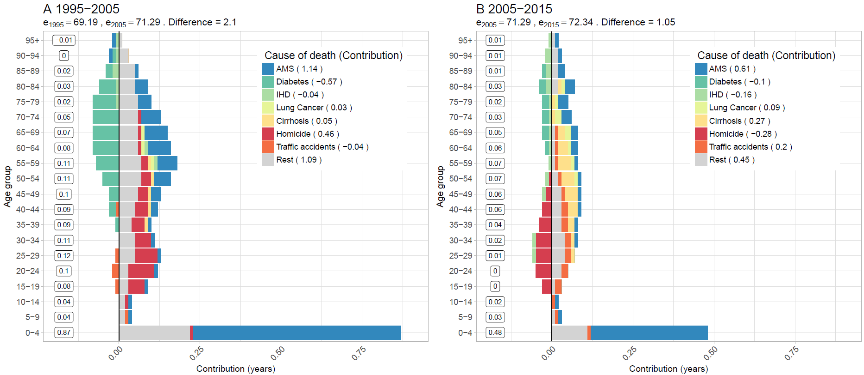**Figure 1. Age-cause specific contributions to the changes in national life expectancy (**e0**) for males. Panel A refers to 1995-2005 and panel B to 2005-2015. Note: Numbers in boxes are age-specific contributions.**

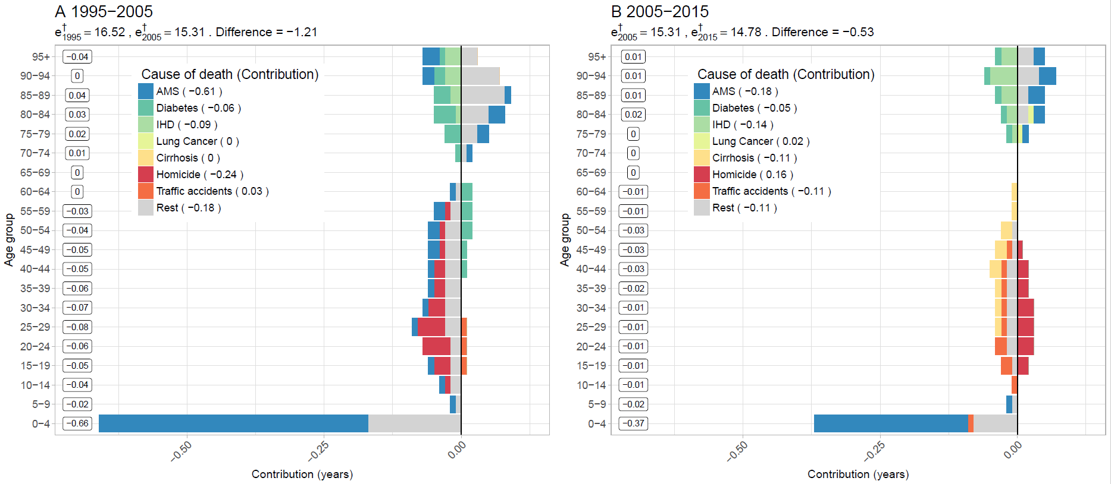**Figure 2. Age-cause specific contributions to the changes in national lifespan variation ($e^{†}$) for males. Panel A refers to 1995-2005 and panel B to 2005-2015. Note: Numbers in boxes are age-specific contributions.**

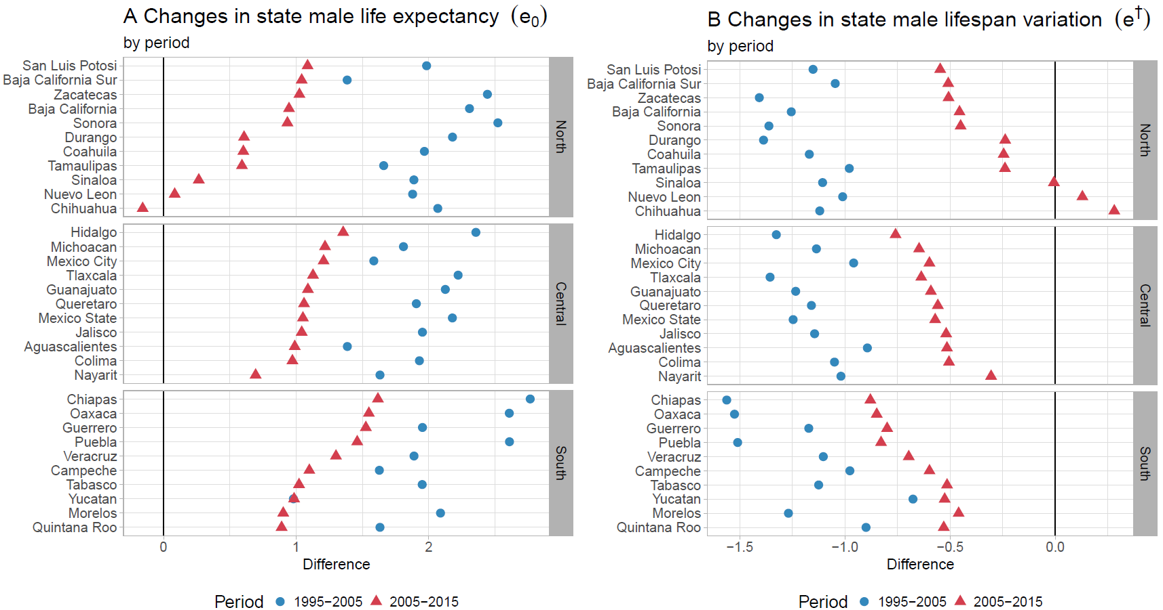**Figure 3. Changes in male life expectancy (**e0**) (panel A) and male lifespan variation ($e^{†}$) (panel B)**

**by state for the periods 1995-2005 and 2005-2015.**

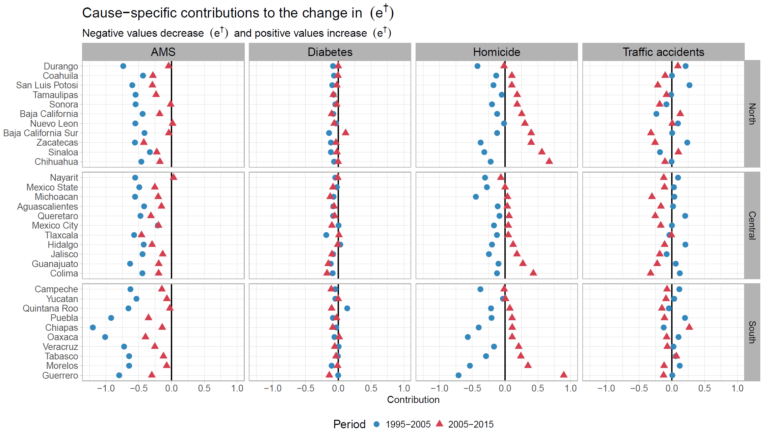**Figure 4. Cause-specific contributions to changes in male lifespan variation ($e^{†}$) by state for the periods 1995-2005 and 2005-2015.**